Patient report
Bio-Rad | DATE:21/09/2021
D-10 | TIME: 18:02
S/N: #DC3E794604 | Software version: 4.20.2
Sample ID: | 1246
Injection date | 21/09/2021 17:58
Injection #: 4 | Method: HbA1c
Rack #: --- | Rack position: 4
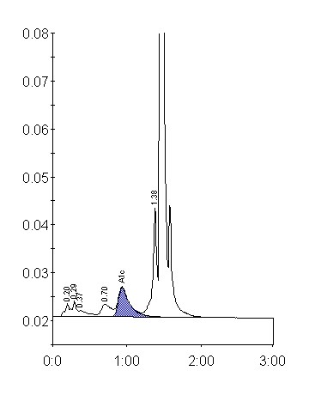
Peak table - ID:1246
 | Peak | R.time |  |  | Height | Area |  | Area %
 | A1a | 0.20 |  |  | 2775 | 12871 |  | 1.0
 | A1b | 0.29 |  |  | 3298 | 10684 |  | 0.8
 | Unknown | 0.37 |  |  | 1230 | 10501 |  | 0.8
 | LA1c/CHb-1 | 0.70 |  |  | 2622 | 24670 |  | 1.9
 | A1c | 0.94 |  |  | 6111 | 64846 |  | 6.8
 | P3 | 1.38 |  |  | 23133 | 84333 |  | 6.4
 | A0 | 1.45 |  |  | 381807 | 1108084 |  | 84.2
 | Total Area: | 1315988
Concentration: |  |  | % | mmol/mol
A1c |  |  | 6.9 | 51

