Patient report
Bio-Rad | DATE: 21/09/2021
D-10 | TIME: 20:07
S/N: #DC3E794604 | Software version: 4.20-2
Sample ID: | 1249
Injection date | 21/09/2021 19:34
Injection #: 6 | Method: HbA1c
Rack #: --- | Rack position: 2
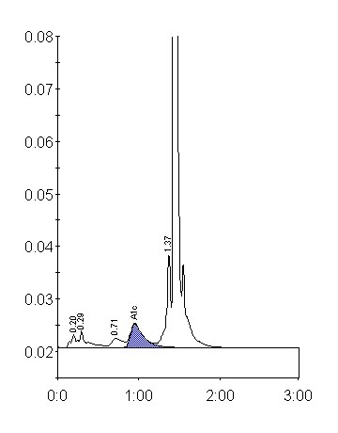
Peak table - ID: 1249
 | Peak | R.time |  |  | Height | Area |  | Area %
 | A1a | 0.20 |  |  | 2490 | 9907 |  | 1.0
 | A1b | 0.29 |  |  | 3262 | 20847 |  | 2.1
 | LA1c/CHb-1 | 0.71 |  |  | 1742 | 16009 |  | 1.6
 | A1c | 0.95 |  |  | 4489 | 50471 |  | 7.1
 | P3 | 1.37 |  |  | 18015 | 64362 |  | 6.5
 | A0 | 1.44 |  |  | 298779 | 827912 |  | 83.7
 | Total Area: | 989508 *
Concentration: |  |  | % | mmol/mol
A1c |  |  | 7.1 | 54

