Patient report
Bio-Rad | DATE: 21/09/2021
D-10 | TIME: 18:03
S/N: #DC3E794604 | Software version: 4.20-2
Sample ID: | 1285
Injection date | 21/09/2021 17:42
Injection #: 3 | Method: HbA1c
Rack #: --- | Rack position: 3
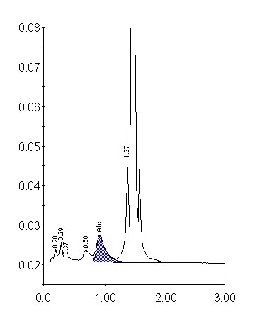
Peak table - ID: 1285
 | Peak | R.time |  |  | Height | Area |  | Area %
 | A1a | 0.20 |  |  | 3223 | 11070 |  | 0.7
 | A1b | 0.29 |  |  | 4916 | 16926 |  | 1.1
 | Unknown | 0.37 |  |  | 1310 | 11495 |  | 0.8
 | LA1c/CHb-1 | 0.69 |  |  | 2893 | 25474 |  | 1.7
 | A1c | 0.92 |  |  | 6734 | 70003 |  | 6.4
 | P3 | 1.37 |  |  | 25729 | 90173 |  | 5.9
 | A0 | 1.44 |  |  | 449480 | 1292664 |  | 85.2
 | Total Area: | 1517805
Concentration: |  |  | % | mmol/mol
A1c |  |  | 6.4 | 46

